Feasibility
Analysis

Share Karo! App

Group Member:

Jharana Shrivastava: U101114FCS073 (S3)
NIIT University

TABLE OF CONTENTS

1. EXECUTIVE SUMMARY
2. DESCRIPTION OF PRODUCTS AND SERVICES
3. TECHNOLOGY CONSIDERATIONS
4. SEEDING SURVEY
5. PRODUCT/SERVICE MARKETPLACE
6. Threats
7. Conclusions
8. REFERENCES

EXECUTIVE SUMMARY

The project “Share Karo” App has been done as a Vth Semester software engineering project development assignment. The Project has been developed by six third year students Akshay Gupta: U101114FCS039 (S2), Anshul Sharma: U101114FCS046 (S2), Ayushi Jain: U101114FCS055 (S2), Ishtaa Sayal: U101114FCS070 (S3), Jatin Kakkar: U101114FCS072 (S3) and Jharana Shrivastava: U101114FCS073 (S3).

The admin rights of the app and the first installment presentation lies with the developers and founders of this app. The app has been purely developed by its founding members with proper division of workforce.

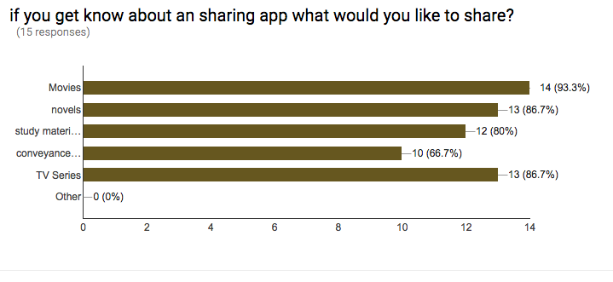
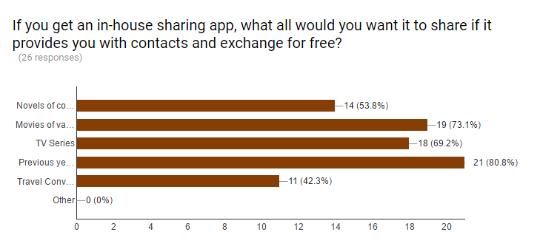

DESCRIPTION OF PRODUCTS AND SERVICES

The project is mainly focused on four features.

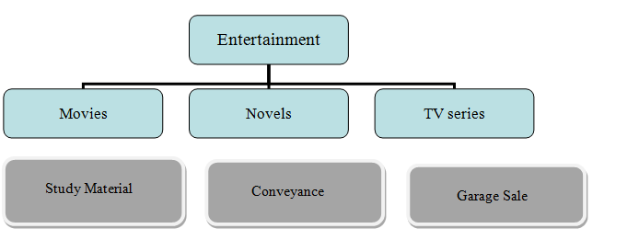

Movie Sharing:

Students (hostellers) mainly like to indulge into movies to pass most of their time in the hostels. Thus, this feature is on the high priority level on the app. The app gives them an option to put up their preferred movies and search for the ones that they feel like watching.

Novel Sharing:

Students (hostellers majorly) like to indulge into novels to pass their time in the hostels and to widen their horizons into the world of literature. Thus, this feature is again on the high priority level on the app. The app gives them an option to put up their collection of novels and search for the ones that they feel like watching.
TV-Series Sharing:

Students (hostellers mainly) indulge into TV series (American mostly) to get an insight into the affairs happening all around the world and to get a peek into the life beyond a particular space. Thus, this is another feature on the high priority level on the app. The app gives them an option to put up their preferred movies and search for the ones that they feel like watching.

Study Material Sharing:

Students prefer their course ppts, projects, important questions papers and presentations with juniors, without any hesitation. Thus, this is another feature on the low priority level on the app. The app gives them an option to put up their used projects and ppts as reference for juniors and search for the ones that their seniors have uploaded and they feel like downloading.

Conveyance Sharing:
Students prefer sharing cabs (conveyance) to a common destination to reduce upon the travel costs and increase feasibility. Thus, this is another feature on the low priority level on the app. The app gives them an option to put up their travel schedule (date, time, source and destination) and search for the ones with same interests. This would provide them with an option to pool.

Garage Sale:

Students prefer sharing the reusable items with their colleagues and peers. The app provides them with a photo upload option so as to upload and share what they want to sell in second hand. Thus, this is another feature on the low priority level on the app. The user can search for the items they desire and can procure the contact of the person concerned with the item.

TECHNOLOGY CONSIDERATIONS

The software is built with the definition of following frameworks:
- The database is designed using the Mongo DB framework.
- The languages (html, CSS, java script, node JS) are built upon the Visual Studio 2015 Enterprise software.
- The software is majorly designed upon the Microsoft Windows OS. However, it is created as a cross-platform forum to work over Linux and iOS as well.
- The Node JS framework: Integration with other Visual Studio features and 3 rd party tools. (Node.js, io.js, JavaScript, TypeScript, HTML, CSS, and JSON support)
- Communication protocols that interface between the front-end and back-end codes.

SEEDING SURVEYS
The company decided to first survey if the project is worth efforts in real-time. The seeding idea was then presented to a few friends who helped in deciding the same.
Here is the link for the same: https://docs.google.com/a/st.niituniversity.in/forms/d/e/1FAIpQLSdQRok8juXlh7KKhXiNcEUZWWn9YxTKTtLWmKertD9MFtg0fA/viewform
Responses recorded while initial surveys:
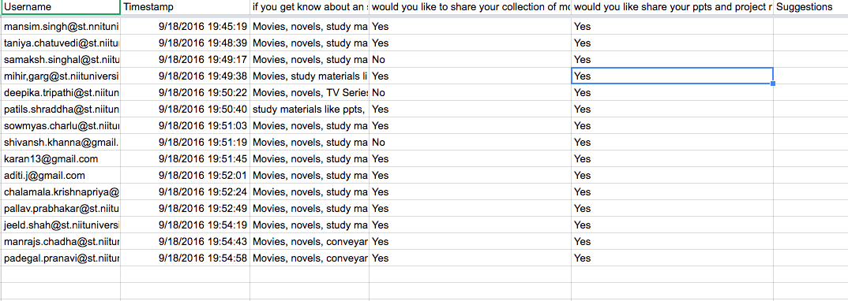
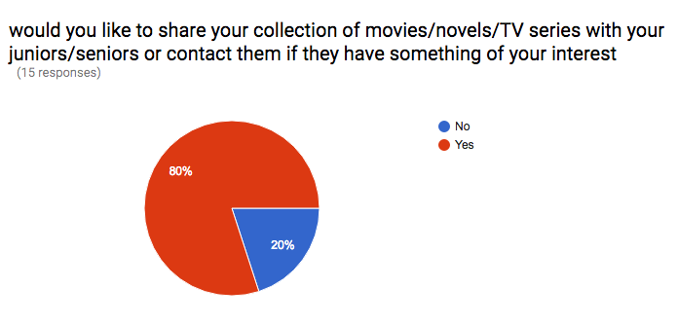

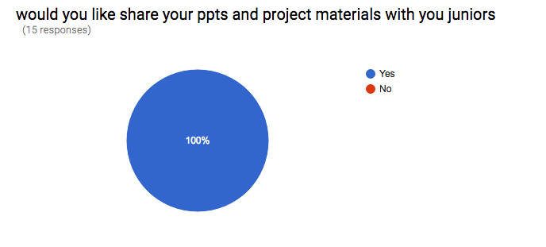

PRODUCT/SERVICE MARKETPLACE

The software has been designed majorly for University students. However, it can be generalized and extended to local area space where people can interact and share their entertainment, study material and conveyance through the app.
The user can sign up with the university/domain login and share their contact (email/phone no) if they feel like. The user needs to explain their interests in particular movie/novel genres so that other users can request them. The user is also allowed to upload the ppts and presentations they created for the juniors to refer. He/she can draw out the details of their journey so as to check if anybody else matches the same. The user can look up under specific headings (entertainment, studies, conveyance) and check if their requirements match any of the ones uploaded and can then contact the concerned person. The user is also allowed to make requests to a specified person for contact regarding the requirement.
Here are the responses that have been recorded for the surveys:
The link to the survey questions: https://drive.google.com/open?id=106nrUHpPJbuwHH0KGF8CrogIt4Tui3VpNfJ0K841ZL8
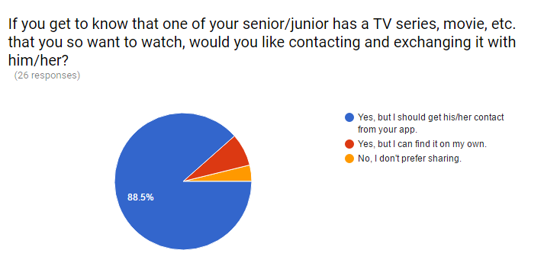
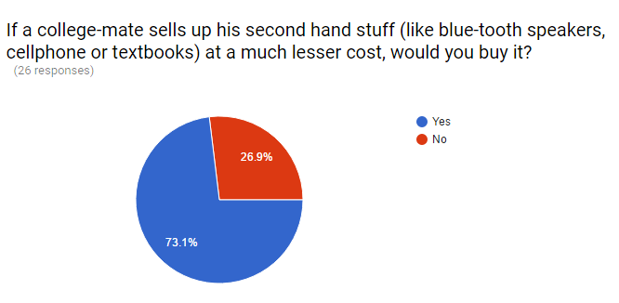
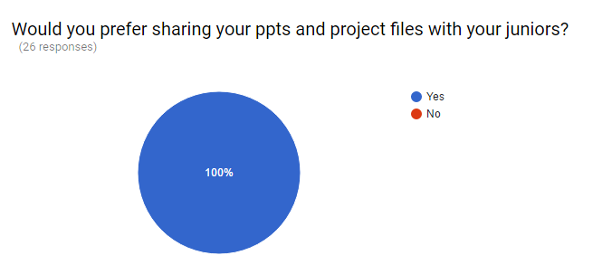
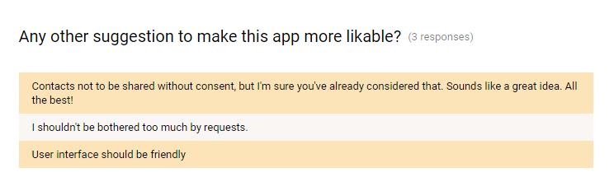

THREATS
The project idea could face serious oppositions or failures if the following conditions are somehow invalidated:
- The people are not willing to share their private collections.
- People are not open to interacting with new people or getting to socialize.
- The physical exchange is not possible between two interested parties.
- The people don’t sign up or update data on the concerned forum and don’t make it visible.
The threats are taken care of in the manner where the app is made completely interactive and lucid for usage. It is considered that students are generally open to socializing and procuring their needed stuff from sources.
The main questions that we tried to answer were:
  - What are current process problems? What if the system wasn’t implemented?
    - The people will have to go on various platforms to find their required leisure time stuff and there are major chances that they won’t end up finding them.
  - How will the proposed system help?
    - The system will provide an easy platform for people to come forward and share their
documents on a common portal and even help in socializing.
  - What will be the integration problems? Is new technology needed? What skills?
    - The integration would require constant update feature and an option to the user
to secure their contacts and share only items that they want to. The admin would
reserve security rights and the function would be implemented by java-scripting.
  - What facilities must be supported by the proposed system?
    - The app should be lucid and comprehendible and cross-platform for easy handling and
access.

CONCLUSIONS
The “Share Karo” App is good to go for the development phase. Most of the suggestions have been incorporated and have mostly been taken care of.
The team has worked hard for designing the USPs of the app that differentiates it from all contemporary substitutes as the app comes with extravagant advantages like:
- Low cost development and management.
- Low memory requirements for operation across systems.
- Cross platform and Open source functioning.
- User friendly interface.
- Privacy protection for the users.
- Easy interaction between users.
- Socializing add-on to the app.
REFERENCES
- http://www.sciencedirect.com/science/article/pii/S0960148108003315
- https://www.researchgate.net/profile/Tom_Baldock/publication/222435805_Feasibility_analysis_of_stand-alone_renewable_energy_supply_options_for_a_large_hotel/links/00b7d518d634e4b798000000.pdf
- https://www.researchgate.net/profile/Tom_Baldock/publication/222296269_Case_study_feasibility_analysis_of_renewable_energy_supply_options_for_small_to_medium-sized_tourist_accommodations/links/00b7d518d634e226bd000000.pdf
- http://www.gis.geo.uj.edu.pl/Teaching_tool_on_knowledge_transfer/eng/wydruki/pdf/Feasibility%20analysis.pdf
- http://www.prenhall.com/behindthebook/0132240572/pdf/BarringerCH03.pdf
- http://wps.pearsoned.com/wps/media/objects/5599/5733471/Appendix_3_1.pdf
- http://www.business.uzh.ch/dam/jcr:00000000-505f-0781-0000-000015ca410a/Kap3primerentrepreneuruka.pdf
- http://sydney.edu.au/engineering/it/courses/info5210/chap09.pdf
- http://msuextension.org/publications/BusinessandCommunities/MT199510HR.pdf
- https://www.google.co.in/url?sa=t&rct=j&q=&esrc=s&source=web&cd=7&cad=rja&uact=8&ved=0ahUKEwjqr9StoZ7PAhUURmMKHRHbB1UQFghIMAY&url=http%3A%2F%2Fnptel.ac.in%2Fcourses%2F106108103%2Fpdf%2FLecture_Notes%2FLNm4.pdf&usg=AFQjCNH3HYemv8J-TkRaHbYozoiIgHIIZw

*************************************************************************************

